**Comodo Firewall** keeps your system protected from threats of malware that can infect your system. Its latest updates include modern technologies for keeping your system safe from harmful attacks and it has been improved to overcome many limitations. It is a licensed product that can be purchased by paying a low price of $39.99, but its trial version is also available for users. Its options are very easy to configure and the layout can be customized according to your personal preferences.

**Installation Procedure:**

You can download Comodo Installer by clicking the published link. When you will open it, the files will be extracted and the installation process for Comodo Firewall will start. You have to choose the language for the tool. You can enter your Email address for receiving news and updates. Then choose settings for the browser integration, security level for browsers, DNS server and other settings. After that you can click Install button for starting its installation. Installing it will disable other Firewalls on your system.



**Support:**

Comodo Firewall is targeted only for Windows OS supported computers. It is compatible with XP, Vista, 7, 8 and 10 versions of Windows Operating System. Your system must have minimum 512 MB RAM with at least 400 MB of free space in your device hard disk. Since it is a large package with support tool and a safe browser, so its size is more than 200 MB.

**Features:**

Comodo Firewall now comes with Viruscope technology that keeps an eye on all the running processes in order to make sure they are not harmful for your system. The Website filtering feature blocks all the phishing or scam websites and thus protects your system from accessing and downloading any malware content. The Live Tech Support is available 24 hours every day for all the users in the category of GeekBuddy. Expert technicians are available and you can chat with them asking for help about any issues.

It efficiently manages the traffic and data transfer into and out of your system via internet. It offers you safe browsing by preventing online attacks from malicious sites and hackers. It also protects your private data from theft.

**Categories:**

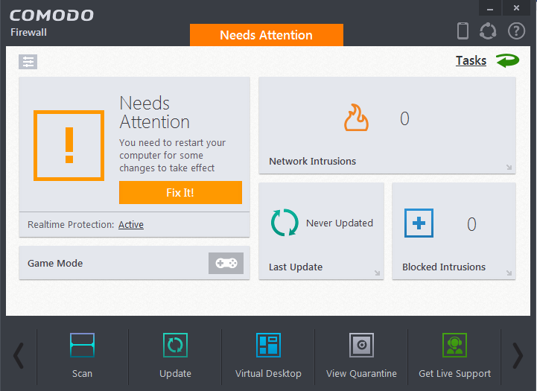

**Scan:**

It performs Scan on your system files to check whether they are safe to use or not. You can then perform suitable action on the infected files.

**Update:**

It checks for the websites database updates, recognizer updates and software updates.

**Virtual Desktop:**

It opens a virtual desktop window on your screen. All the running programs can be accessed. You can also toggle the view between Classic mode and Tablet Mode through the settings.

**View Quarantine:**

It contains the list of items that were detected to contain viruses along with their details.

**Conclusion:**

Comodo Firewall is a preferred choice for keeping your system secure. It efficiently maintains the high security level of your system and saves you from hackers’ attacks. It lets you browse internet in safe mode and warns you of the suspicious connections and websites. You can use various tools for scanning and saving your system from harmful threats. It is a complete package of firewall and browser that provides you better internet security.